December 2023
Knights of Columbus Newsletter
Council 9096 Apple Valley, MN
www.kcapplevalley.org
Upcoming Events  12/04 9am Food on the 1st at RS  12/17 KofC Pancake Breakfast w/Santa  12/19 KofC Rosary 7pm & Meeting 7:30pm  12/31 Family Rosary at Risen Savior  1/13-14 Cinnamon Roll Sales  1/16 Council Spaghetti Dinner  Inside This Issue  Grand Knight Report  November Meeting Minutes  Refreshment Schedule  November Food on the First Results  BJ and Patty Bertram Christmas Light Display  KofC Pancake Breakfast with Santa  Knights of Columbus Council 9096: 2021/2022 Officers:  Chaplain TBD  Grand Knight Dan Hindes 612-237-4794  Deputy Grand Knight Rex Huttes 612-859-7314  Chancellor Vacant  Financial Secretary Andy Howard 952-917-9959  Treasurer Steve Lorenz 612-501-4211  Recording Secretary Tim Blodgett 952-215-2454  Warden Bill Kelly 612-419-9269  Advocate Steve Dahl 612-987-9521  Inside Guard Jeff Konkol 414-477-0478  Outside Guard Peter Sebastain 651-785-8866  Lecturer Vacant  Trustee #1 Todd Laubach 612-590-8631  Trustee #2 Gary Keller 952-212-2638  Trustee #3 Dave Peterson  Membership Jeromy Darling 952-484-1188  District Deputy Steve Lorenz 612-501-4211  KC Insurance Field Representative:  Chris Massoglia 651-334-1290763  chris.massoglia@kofc.org | Grand Knight Report  Brother Knights,  December! The meteorological beginning of winter; a time to reflect as we prepare for the birthday of Jesus. As we decorate our homes, let us do so in His honor. As we gather with family and friends, let us do so in His honor. As we exchange gifts, let us do so in His honor. As we mend fences and relationships, let us do so in His honor. And let us carry this theme, “All for the greater honor and glory of God” into 2024!  Oh, by the way, I share the same birthday. If I had a dollar for every, “wow you’re a Christmas baby” or/and “don’t you get cheated on presents,” I would have quite the little nest egg. But, as I grow older, the birthday is not about me, but rather “Jesus is the true reason for the season.” Let us prepare and celebrate!  Shifting gears – please mark your calendars for the date of our January 16th meeting. We will be having a spaghetti and meatball dinner for knights and spouses. Final details are being worked out and will be forthcoming. We will need a quick RSVP response when requested (translate: how many meatballs and how much pasta and sauce etc. will we need).  Just a reminder that Risen Savior has weekly exposition and adoration of the Blessed Sacrament, the Eucharist, on Friday’s from 930am (after Mass) to 7pm. Drop in at any time! During the last hour there is a holy Hour with Benediction.  A blessed Christmas to you and your families, from our house to yours.  Vivat Jesus  Dan Hindes, GK  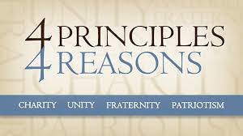
KC Apple Valley/Risen Savior Council 9096
Meeting Agenda
November 21, 2023
- Call to Order by GK Dan Hindes -- Meeting began at 7:35
- Opening Prayer led by GK or chaplain.
Prayer was let by Chaplain
- Pledge of Allegiance led by GK Hindes
- Approval of Prior Meeting Minutes with clarifications (motion required)
Minutes approved unanimously
- Chaplain’s Message --
- Introduce Guest(s) -- No guests
- Grand Knight’s Report
- Treasurer’s Report (NO motion required)
- Financial Secretary’s Report -- Secretary not present
  - Membership Status -- Membership increased by one (1)
  - Unpaid Dues Status --
  - State Raffle tickets will be sent with dues notices. Council raffle tickets will not.
- T-Shirt and Apparel Ordering Discussion -- BJ Bertram
BJ suggests putting together an order for embroidered shirts only to save money. Extra caps will be ordered to bring cap order to six (6). Idea was accepted. Order form will be sent out with dues notices.
- Membership Report (Tim Blodgett}
Tim has reached out to (3) prospects at the Pancake Breakfast.
- Program Reports/Status towards Faith In Action Columbian Award Requirements
  - Life/Faith Terry McCall
    - 11th November -- Cinnamon Roll sales were a success
    - Pregnancy Choices Ultrasound will be $30k, Supreme matches council donations dollar for dollar. Our goal is to raise $2500. There is also a website for additional donations. Our council is leading the effort to raise the funds for the machine. An account still needs to set up the funds. Steve Lorenz will request a list of Council contact information from State. Excess funds will go to the ASAP program, and will be matched 40% by Supreme. An additional line item for donations will be included in the dues letters.
    - January 22nd March for life will be held at Noon on the steps of the State Capital.
  - Faith Jerry Kuennen
    - 13 attendees at the last family Rosary on October 29th
    - The next Family Rosary will be 12/31/23 at 10am
  - Community Bill Rabe
Thanks to everyone who helped with Turkey Bingo on 11/4/23
Very successful. Basement was filled, more than 300 people in the Hall.
BJ Bertram found a soda sale at Walgreens that reduced food costs.
  - Family/Council BJ Bertram
Knights will help with Christmas decorations on 12/23. All the help that’s needed is already in place. Decorations will be taken down after Epiphany.
- Other Reports
  - Event Chairs
  - Next Pancake breakfast on December 17th. Donations are at average. Next breakfast will have Santa Claus and piano players.
  - Fourth Degree
Father Malek was presented with a sword by the 4th degree assembly
  - Insurance -- Presentation was watched before the meeting
  - District Deputy
Next district meeting at the beginning of December
- Old Business
- New Business
  - Upon recommendation of Financial Secretary, a motion to maintain annual dues at $40/yr for 2024 was approved.
  - Joint effort with Watchmen KC’s encouraged to attend next meeting 630pm 11/28
Monday night. All Knights are encouraged to attend. Father Malek will be speaking on discerning the Holy Spirit.
  - Spaghetti Dinner to be held in lieu of January 16th meeting. Signups for salad, breadstick, and drink providers to be determined in December
- Chaplain’s Message
Father Malek expressed his gratitude for the events the Knights perfom on behalf of the Parish. He appreciates the hospitality and opportunity for fellowship within the Parish.
- Good of the Order
- Prayer Requests and Closing Prayer
- Motion for Adjournment @ 8:29
- Next Meeting: 12/19; 7pm Rosary; 730pm meeting
- Social/Refreshments

Respectfully submitted by Cameron Hoppe, Recorder

Monthly Meeting Refreshment Schedule
Monthly Meeting is conducted in the Risen Savior Church
Bays 1 and 2 on the Third Tuesday of each Month at 7:30 PM
Effective Date: July 1, 2023
KC Meeting Date | Name | Telephone Number
December 19, 2023  Tuesday 7:30 PM | Jeff Konkol | 414-477-0478
January 16, 2024  Tuesday 7:30 PM | Spaghetti Dinner  Steve Lorenz | 612-501-4211
February 20, 2024  Tuesday 7:30 PM | Bill Rabe | 612-940-2792
March 19, 2024  Tuesday 7:30 PM | Koffi Koumedjro | 612-245-4932
April 16, 2024  Tuesday 7:30 PM | Andy Howard | 952-917-9959
May 21, 2024  Tuesday 7:30 PM | Roy Tangeman | 319-360-2756
June 18, 2024  Tuesday 7:30 PM | Jerry Kuennen | 952-236-7523
Your Refreshment Guidelines:
-$60 Monthly Refreshment Budget (Please bring receipts to KC Meeting for reimbursement).
-Use your own cooler.
-Bring 20 to 24 Beers, 12 Pop, and 4 Water.
-Bring snacks to share such as peanuts, chocolate, crackers, cheese, etc.
-The refreshments and snacks that are not consumed are yours to take home
-Our KC Newsletter will list the person responsible for the monthly refreshments.
-If you cannot fulfill your monthly assignment, please contact another Knight on the schedule.

October Food on the First Results

As part of the Risen Savior Food on the First Program, the Risen Savior Knights of Columbus delivered 783 pounds of food to the Burnsville 360 Communities Food Shelf on November 6, 2023 (Monday), Since July 1, 2023, the Knights have delivered 4113 pounds of food to the Food Shelf.

The Food Shelf was grateful for food because their food supplies were low.

BJ and Patty Bertram Christmas Light Display

Enjoy a 25,000 Christmas Light Display that features a unique Nativity Scene with a 5-foot star on the house that has lights cascading to a 15 foot ground star that contains the Stable with Mary, Joseph, and Baby Jesus. The children will enjoy seeing Santa counting down the days to Christmas. Rudolph, Blitzen, the Sleigh and 42 snowflakes are on the garage roof. For your listening pleasure, the Crab Tree Lights are synchronized to Christmas Music. The display has won several Burnsville Christmas Lighting Contests. The lights are turned on from 5:00 to 10:00 through January 1. Our address is 15113 Stevens Avenue in Burnsville.
Sunday December 17th Knights of Columbus Pancake Breakfast with Santa

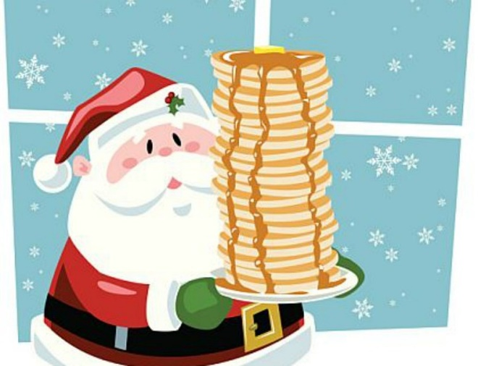
The Risen Savior Knights of Columbus are having a Pancake, Sausage and Fruit Breakfast on December 17 (Sunday) from 9:30 AM to 12:30 PM in the Risen Savior Resurrection Hall. Treat your family to a delicious breakfast and some Christmas Cheer.
After the 9:00 and 11:00 Masses, Santa will visit and hand out candy canes to your children and grandchildren. In addition, your favorite Christmas Carols will be played on the piano.
At the Pancake Breakfast, the Knights will have raffle tickets for sale to be used to fund Risen Savior High School Scholarships.

If you are interested in volunteering for a short shift at the Pancake Breakfast, please contact Steve Dahl at (612) 987-9521 or at jsdahl@comcast.net.

Sunday December 31st Family Rosary at Risen Savior

The Rosary will be prayed in the chapel at Risen Savior at 10am following the 9:00 Mass. Praying the Rosary shows our dedication to Our Lady and grants us her protection. It also brings us closer to Christ, more faithful to Him, and opens us to receive God’s blessings in our lives. Please join your fellow Knights in this opportunity to pray the Rosary with the rest of the Risen Savior Community.

