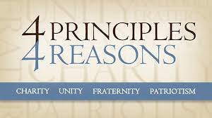
`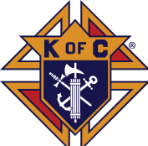
Grand Knight Report – by Gary Keller

Brother Knights

GOOD NEWS! It was good to be back at a physical meeting at our last meeting. And the social time was great too!! Note that our regular meeting will now begin at 730pm and the Officers Planning meeting before that at 7pm.

We are still looking for candidates to run and fill offices in our council.
Requirements are;
- You are a 3rd degree knight (we can get you to 3rd degree in a matter of 35 minutes!)
No experience is necessary, we will train you! If you have any questions, please call me at (952) 212-2638.

See the newsletter article for the opportunities.

Remember to attend our General Meeting in the RS Basement 18 May.

Vivat Jesus.
Fraternally,
Gary Keller
Grand Knight
Apple Valley Council 9096
Upcoming Events
- 6/15 Monthly Meeting 730pm @RS!
- 6/15 Monthly Officers Meeting 7pm
- Walk for Life (August TBD)
- 8/17 – Council Family Picnic
- 8/29 – Family Rosary
- 9/5 – RS Charter Mass
Inside this Issue:
- Grand Knight Report
- Meeting Minutes
- RSVP Seminarian Update
- St. Michael’s Medals
- Raffle Winners
- RIP
- Advertisers
Knights of Columbus Council 9096: 2020-2021 Officers:
Chaplain Fr. Tom Krenik 952-431-5222
Grand Knight Gary Keller 952-431-2638
Deputy Grand Knight Paul Luhman 612-889-1383 Chancellor Greg Konkol 414-344-8188
Financial Secretary Andy Howard 952-917-9959
Treasurer Steve Lorenz 612-501-4211
Recording Secretary Dan Hindes 612-237-4794
Warden
Advocate Steve Dahl 952-892-0383
Inside Guard Peter Sebastain 651-785-8866
Outside Guard Bill Rabe 612-940-2792
Lecturer Dave Commerford 952-432-9398
Trustee #1 Richard Ehalt 952-432-5317
Trustee #2 Dave Peterson 952-233-8918
Trustee #3 Todd Laubach 612-590-8631
Membership Dan Hindes 612-237-4794
District Deputy Joe Hajdjuk 952-270-1041

KC Insurance Field Representative:
Chris Massoglia 651-334-1290763
chris.massoglia@kofc.org
June 2021
Knights of Columbus Newsletter Council 9096
Apple Valley, MN www.kcapplevalley.org

MINUTES OF KC COUNCIL 9096 APPLE VALLEY, MN

Date: May 18, 2021

The Rosary was prayed before the opening of the meeting.
GK Gary Keller called to the meeting to order at 7:25 with opening prayer and the Pledge of Allegiance.

Minutes: Minutes from the April 2021, meeting were approved as published. MSA

Chaplain’s Report: None

Grand Knight’s Report: We are now meeting live at RS live.

Treasurer’s Report: report as of 4/30/2021 MSA
11
Checking $ 12,991.71 Less outstanding checks & obligations ~ $3600
Money Market $ 10,010.66
TOTAL $ 23,002.37

Financial Secretary’s Report: None

Communications: None

Membership/Applications/Transfer/Retention. We have a new 3rd degree member, Jeromy Darling who was exemplified on 5/5. He plans on being at our June meeting. Welcome Jeromy!.

Program Director’s Reports GK Gary Keller
- Program Director’s Appointments for Fraternal Year 2020/2021
  - Faith: Jerry Kuennen
  - Family and Council: BJ Bertram
  - Life: Dave Commerford
  - Community: Andy Howard
- Reports
  - Faith Family Rosary will resume August 29th
  - Family/Council There is a request for the 4th degree to participate at Fr. Tom’s last Mass on 6/20. Also, our council will present a certificate of appreciation and a $200 check to him. Fr. Gorman left 70-80 pieces of art to the parish. A silent auction is being planned alongside our November 14th pancake breakfast. In the past this has been successful not only for the auction, but our pancake breakfast as well. BJ gave us a reminder that another group will be finishing up their meeting as we begin to arrive for our meeting and encouraged us to just be patient while they leave. For the 50th parish anniversary, the KC’s are in charge of the Charter Mass. BJ has the lead and will be asking for our help for that 5pm Mass in September. The following week will be the celebration meal which will be catered. Right now, our first pancake breakfast is scheduled for October.
  - Life: None
  - Community: None
  - Other Committee/Event Chairman Reports
  - 4th Degree: Report of Honor Guards. 4th degree is planning a Blue Picnic and the question was raised if our council should offer to help. Since our council has not been approached and the picnic is right around the corner in mid-June, no action is needed by our council.

Insurance Field Agent: None
  - District Deputy: Although not our DD, GK Gary Keller asked council member Dan Hindes and DD54 for any updates. The council was briefed on the Supreme Covid 19 Recovery Plan and what it means for our council. Essentially the GK (and whomever else he wants to accompany him) is to meet with the pastor to offer our council’s help in developing a plan to help the process of bringing people back to Mass and involved. Since we will not have a new pastor until July 1st there is not much we can do right now except to continue working with parish staff. After said meeting the GK meets with the DD to review the plan and to discuss a council self-assessment. The last steps are communicating the plan to the council and getting membership involvement. As examples, Dan mentioned that at his District 54 councils, some activities have already begun: restoring hymnals to the pews or restoring pews that were damaged by the harsh COVID 19 disinfectants that were used. He also reminded the council of the current membership incentives available to our council.
Unfinished Business:
Review of Officer Slate for 2021/2022.
Officers slated for election thus far (please consider taking a vacant position)
Grand Knight | Gary Keller | Deputy Grand Knight | Vacant
Chancellor | Vacant | Financial Secretary | Andy Howard
Treasurer | Steve Lorenz | Recording Secretary | Dan Hindes
Warden | Vacant | Advocate | Steve Dahl
Inside Guard | Peter Sebastian | Outside Guard | Bill Rabe
Lecturer | Vacant | Trustee 1 Year | Rich Ehalt
Trustee 2 year | Dave Peterson | Trustee 3 Year | Todd Laubach

Faith In Action Program Directors (not elected)
Overall Program Director | DGK Vacant | Community | Andy Howard
Faith | Jerry Kuennen | Family | BJ Bertram
Life | Dave Commerford | Membership | Dan Hindes

New Business:
Rich Ehalt brought up the problem of not knowing when a Knight or a member of the Knights family has died or is ill and needs our prayers. Dan will put something in the newsletter.
There were no new unbudgeted bills for approval.
The 2021/2022 Council Budget Meeting will be June 7th at 7pm at the home of our GK. This meeting is for all officers, program directors and committee/event chairs. Address details will be forthcoming since the GK is in the midst of moving.
Good of the Order:
Knight of the Month Award
Family of the Month Award
Other Awards
- The scholarship raffle drawing was conducted at the end of the meeting. (see newsletter article)
Lecturer’s Reflection (optional)
“Let us now listen to the Worthy Lecturer’s Reflections”. (If not done during social time)

Grand Knight’s Summary None

Closing Prayer: “Before proceeding with the closing prayer, let me ask: Does any brother knight know of a member of this council, or brother of the Order, who is sick or in distress”? (names are omitted for privacy)

Let us now recite the Prayer for Canonization of Blessed Michael McGivney (or Litany of Blessed Michael McGivney) as we pray for the sick and distressed, and close the meeting.

Adjournment: Motion for adjournment
The meeting adjourned at approximately 8:30 pm and the closing prayer was led by Grand Knight Gary Keller

Next Meeting June 15th 7:30pm at Risen Savior

Next Officers’ Planning Meeting June 15th, 7pm before the council meeting. This meeting is open to any member wishing to attend. If you want something considered at the next Council meeting, you need to have it brought up at this meeting.

Refreshments/Social: Dan Hindes
Recorder: Dan Hindes

RSVP Seminarian Update
Our council has been providing annual support to seminarian John Utecht for the past several years, under Supreme’s RSVP program. He was ordained a deacon on May 8 and joined the parishioners of his hometown parish of St. Elizabeth Anne Seaton for Mass on May 9th. Congratulations to John for coming one step closer to the gift of the priesthood!

St. Michael’s Medals
St. Michael Medals Do you have a family member or friend serving in the military? Request a St. Michael Medal to be sent to them from our State Chaplain. There is no cost to you or the military service person. The military person does not need to be a man, a Knight of Columbus, or a Catholic. Send the name of the person in the military, their rank, branch of service, and address to State Chaplain Fr. Gabriel Walz (statechaplain@mnkights.org). He will send the medal (and a prayer book if requested) directly to the serviceman/woman. Please email your requests to: statechaplain@mnknights.org Prayers from our Minnesota Knights families are very important to our military men and women. Continue to pray for them and their safety

RIP

Too often we do not hear at all, or too late have a KC presence at a visitation or funeral of a brother knight. PLEASE if you hear a name at Mass that you recognize, or you know of a brother knight, please let our GK Gary Keller know: 952-431-2638 kellergl@msn.com

Knights of Columbus 2021
Scholarship Raffle Winners

Leslie & Brad Penrith $500
Avis Flottemesch $100
Jennifer & Tad Mukai $100
Jerry Kuennen $100
Andrea Kuennen $100
Ben San Juan $100
Joseph Ocel $100
Beth Rabe $100
John Hunter $100
Scott Goetl $100
Bob Hansen $100
Total Payout $1,500
Monthly Meeting Tuesday, June 15th 7:30PM (RS Basement)

Officer’s Planning Meeting Tuesday
June 15 7:00 PM (RS Basement)

Please come and participate in the virtual meeting. A zoom invite will be sent out in advance.

PLEASE SUPPORT OUR ADVERTISERS

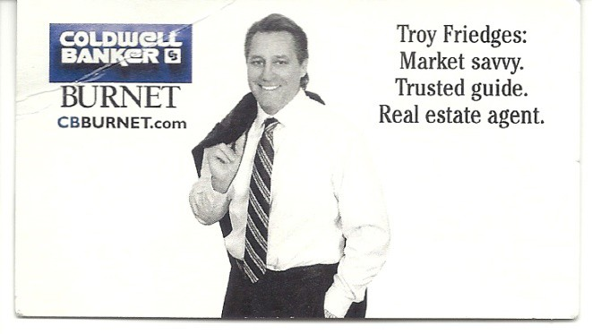

You’ll find your fun with
the largest selection
of name-brand motorcycles, ATVs, personal watercraft, ATVs And snowmobiles in the area!
(952) 435-5371

MAYIA BMW
CAN-AM CF MOTO
KAWASAKI MOTO GUZZI
SUZUKI
VESPA/PIAGGIO SEA-DOO/SKI-DOO JET-SKI

